Delta would like to create a PDF document that can be printed on demand from the Mill Order and include any ‘other charge’ items that are listed on the related sales order (the sales order which the mill order was created from).

The format for the PDF should have the same header as the Mill Order PDF (see below).

* Address in top left
* Mill Order and Number/Date in top right
* Table section with project name, customer order #, line number, due date, sales rep, customer name, sample reference MO and control sample type

Next section should be update to have a table, but defined as follows:

* Left column includes the items from the related customer order that are NOT type assembly and have the checkbox Mill Order Print box set to TRUE. (this will be a new field we create on the item, already created in sandbox).

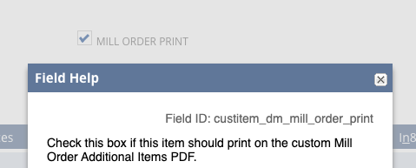

Example:

Lower section table could look like this:

(first column = item number. Second column = Sales Order Notes from the customer order. See order #CO101449)

| Touch Up Paint | Custom Finish- Sample #15815-1, 4860, 2 GALLONS |
| --- | --- |
| Touch Up Paint | Direwolf, 5860, 2 GALLONS |
| Hardware | Box of nails |

